Task 3 Report

# Web Application functionality

This web app is an Address Book and is used to store and show information on contacts that are in the database. There are tabs on the right side of the site that has letters that, when clicked, show contacts whose last name ends in that letter.

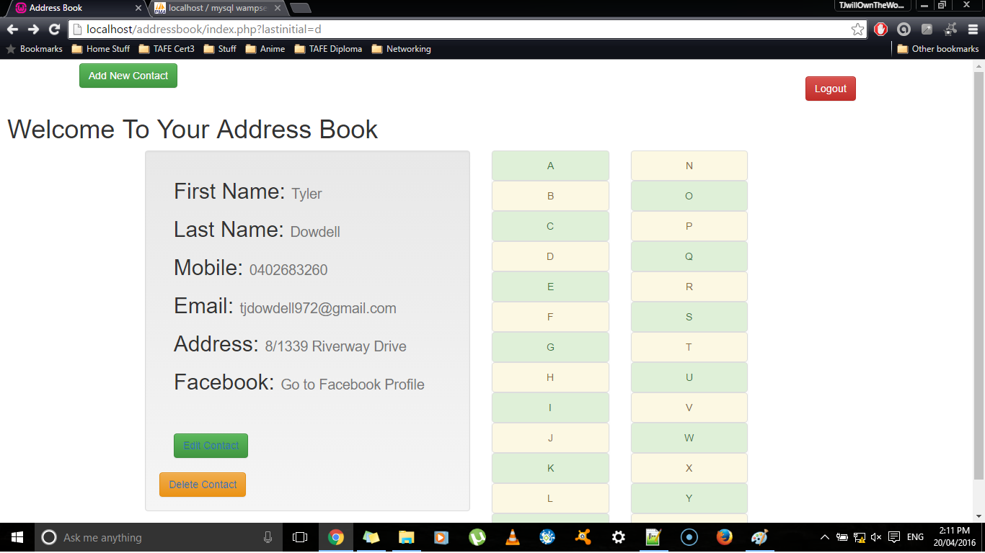

This site has a log in screen which is the first page that shows up if you have not logged in to the address book for that session, you cannot access any part of the site until you have logged in.

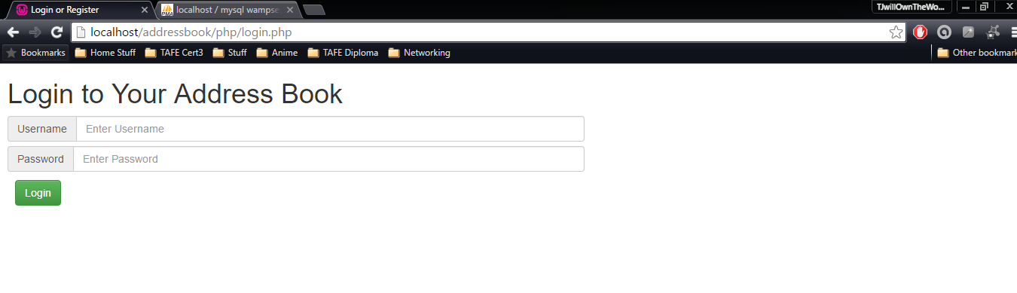

You can also add, delete and update contacts through the site, you do this by clicking on the contact’s last initial from the tabs on the right, which shows their details as well as links to update or delete that particular contact.

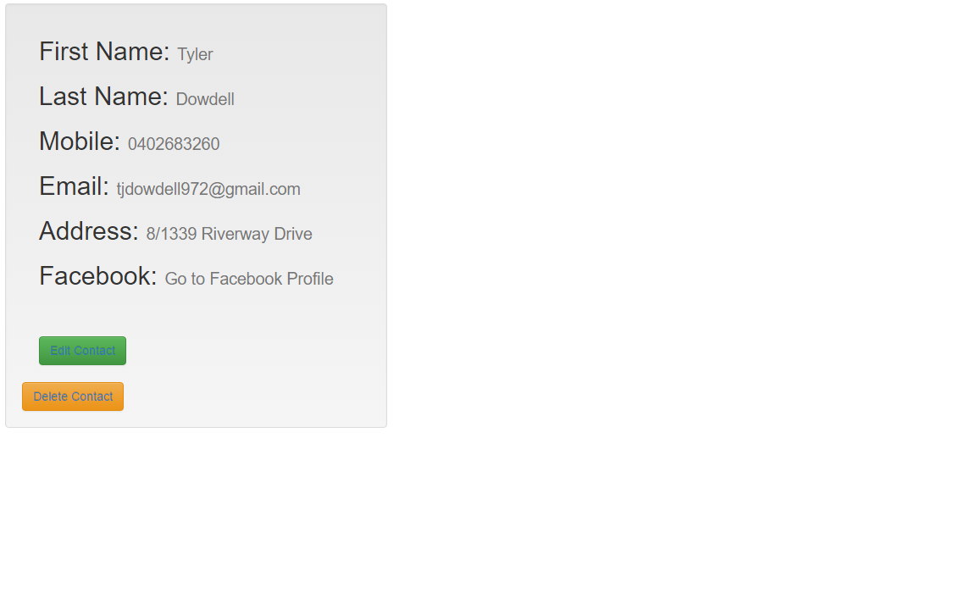

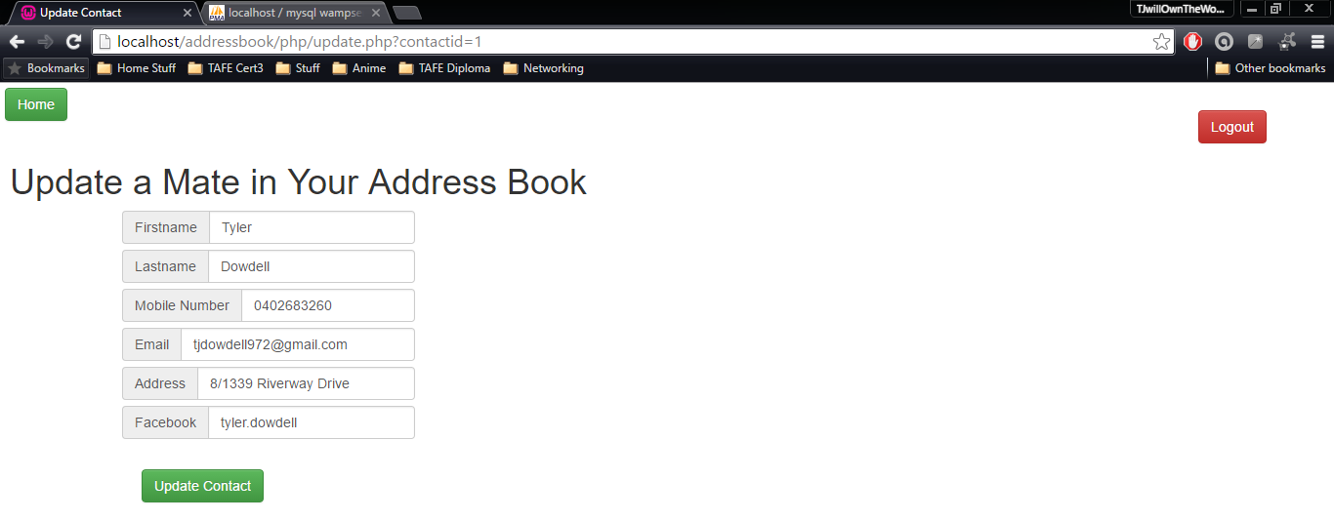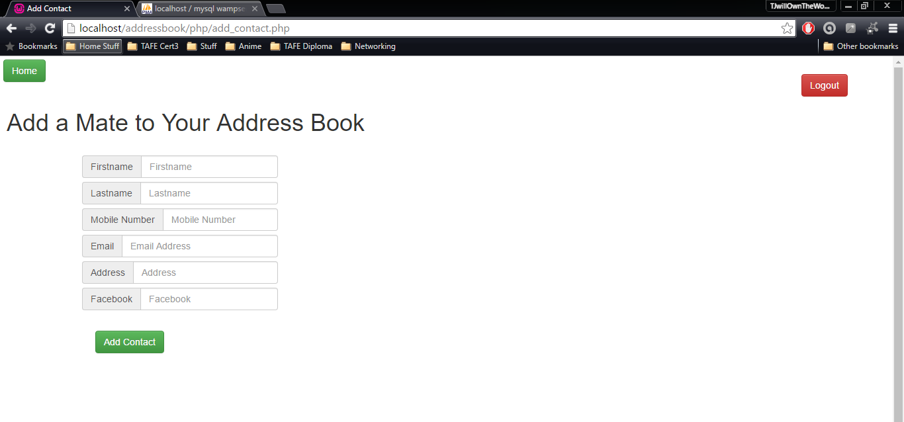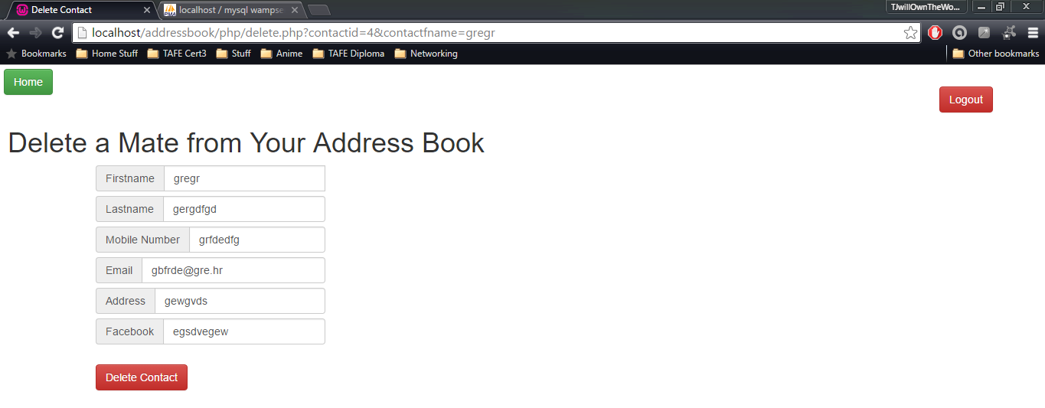

# Database Structure

The database is a simple database with two tables; Contacts and Users.

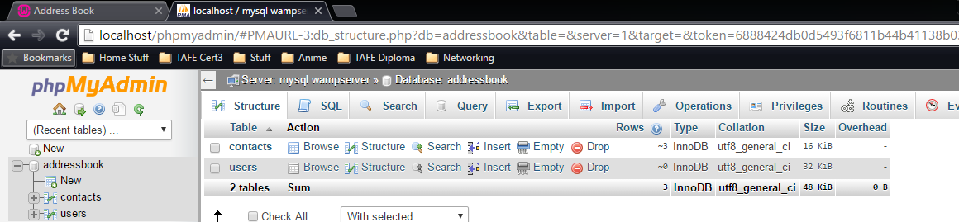

The Users table has three columns in it, User_ID, Username and Password.

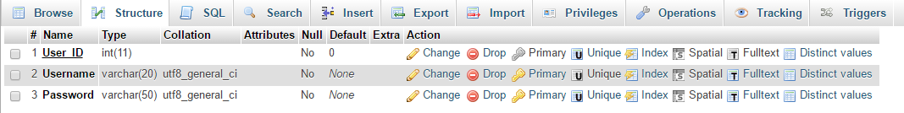

The Contacts table has more columns in it since this table requires more information to be inputted. This table has seven columns, Contact_ID, First_Name, Last_Name, Mobile, Email, Address and Facebook.

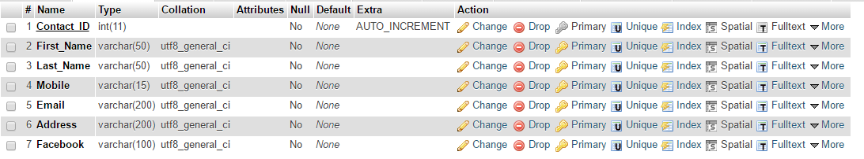

# PHP/SQL Code

The PHP code that I used for this web app so that it can connect to the database was;

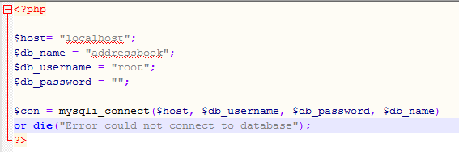

Code that I used to print information from the database to the address book;

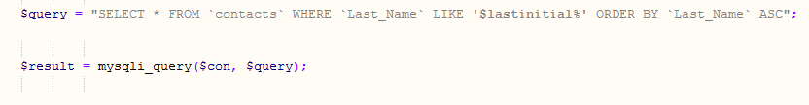

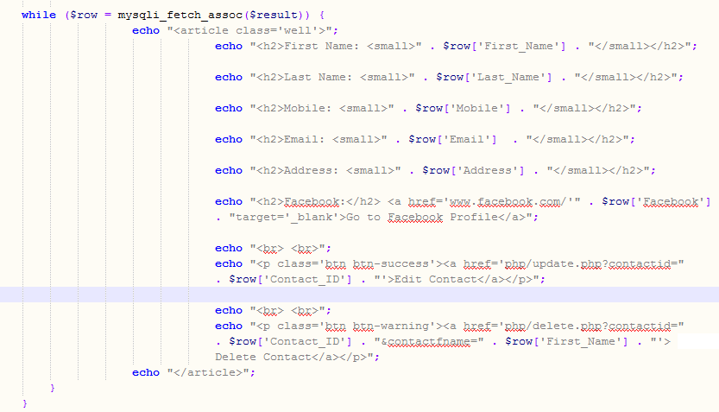

Code used to add contact

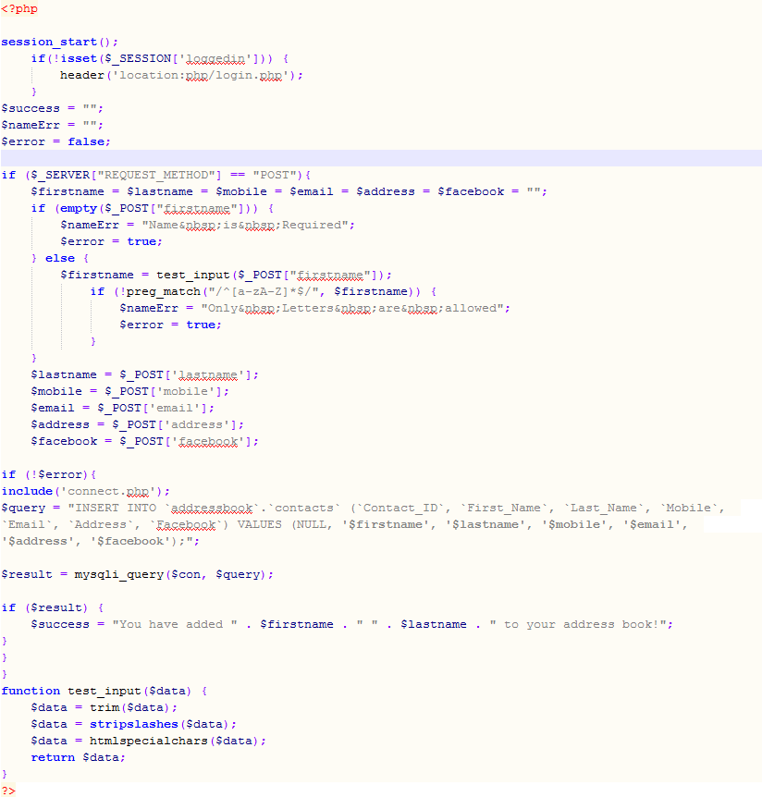

Code I used to update contact

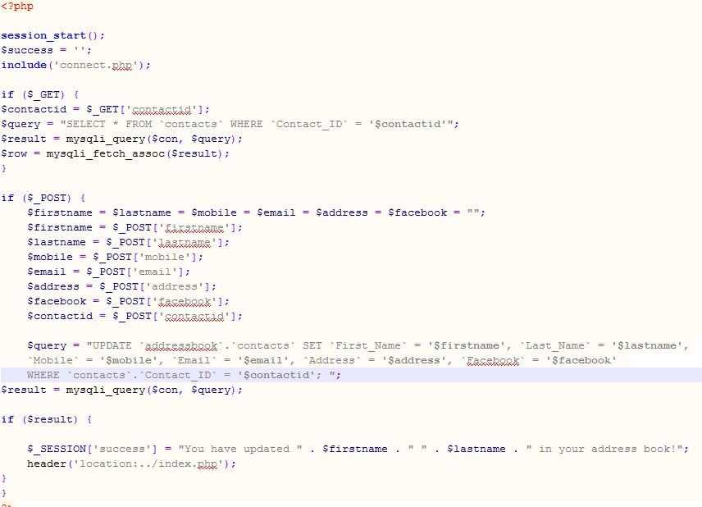

Code I used to delete contact

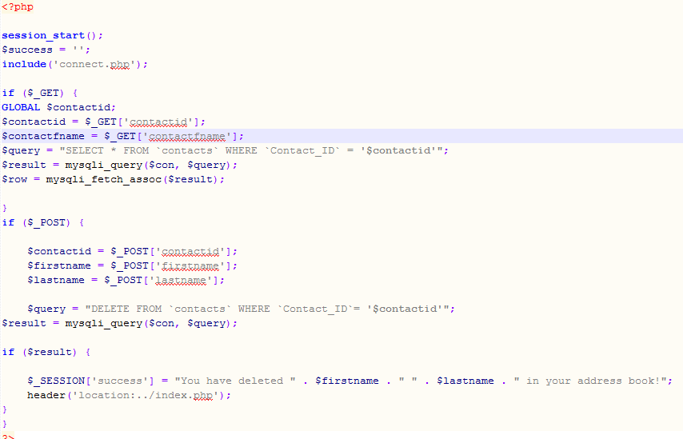

Code I used to Log in to the web app

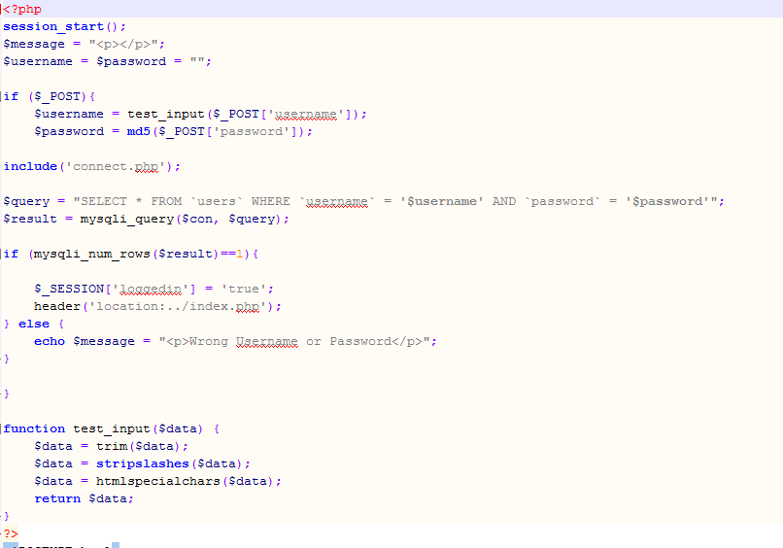

Code I used to Log out of the web app

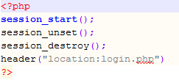

Code I used for validation (Add contact page for first name entry)

